

Town of Wayland
Board of Assessors

Fiscal Year 2020 Assessment Information

October 21, 2019

Wayland Property Owner,

This informational booklet is intended to assist you with understanding your assessment and how the assessment process works.

Fiscal Year 2020 was an “Interim Year” with the Massachusetts Department of Revenue Division of Local Services (DLS) for the Town of Wayland. According to Massachusetts General Laws, assessments must undergo a revaluation program (certification) every fifth year that is audited and certified by the DLS, and Wayland went through that process last year, Fiscal Year 2019. The Town of Wayland’s next certification year will be for the FY 2024 assessments. Interim year adjustments are required in the years in between certifications to keep property values in line with the market. The DLS reviews a much more limited amount of data during interim years but still must approve the sales file and other submissions.
The goal of the valuation process is for the values of all properties to be fair and equitable both relative to similar properties and proportionately when compared to all properties. All of the necessary market analysis and valuation steps are taken in order to determine values for all properties within a municipality. The equalization of the values within a city or town creates a fair distribution of the tax burden. The purpose of the valuation process is not to raise taxes, which is controlled by the town budget process. The purpose is to create an equitable distribution of the tax load.
For the Fiscal Year 2020 assessments the Board of Assessors used sales that occurred during the calendar year 2018 for single family and residential condominium properties (per DLS guidelines) to establish the assessed value of your property. For all other property types, calendar year 2017 was also used, again per DLS guidelines. Several spreadsheets of relevant data and other information are available on the Assessors’ Office webpage of the Town of Wayland website.
Please do not hesitate to contact the Assessors’ Office if you have any questions or concerns regarding the assessed value of your property: 508-358-3788.

READING YOUR PROPERTY RECORD CARD

1. Property Location: The actual physical location of the property being valued.

- Map ID: The Map/Block/Lot/Unit of the property. This is created by the Town and used to reference tax maps.

- State Use: This is the current use of the property (i.e.: 1010, single family). These codes are the codes the State of Massachusetts Department of Revenue Bureau of Local Assessment recognizes.

- Topo/Utilities/Street/Location: These items are purely descriptive of the property and do not generate value.

- Appraised Value: The total of all Buildings, Extra Features, Outbuildings and Land. This is the current market value of the property.

- Assessed Value: The total of all Buildings, Extra Features, Outbuildings and Land. The assessed value also takes into account any Chapter Land valuations (agricultural use not to be developed) as opposed to the full market value of the land. For properties without Chapter Land, the Assessed and the Appraised value will be the same.

- Exemptions: This section is generated by the Town. This will show any exemptions that the current property owner received.

- Other Assessments: This section is generated by the Town. Typically any Betterment will be found in this section.

- Appraised Value Summary: This section provides a full overview of all Buildings, Extra Features, Outbuildings, Land and Special Land Values. Each line item is shown rather than a lump total value.

- Assessing Neighborhood: This shows the neighborhood and sub neighborhood the parcel falls into. In this case, the item is descriptive only and does not generate value.

- Notes: The notes provide the Town with generalizations about the property such as the color, the interior and exterior general conditions and any other items the Town wishes to include. All notes are descriptive and have no value attributed.

- Building Permit Record: Any Building Permits taken out on the property will be recorded here. Town generated field.

- Visit/Change History: Any visit to the property by the Town, Agent of the Town, MLS data or other reliable sources can be recorded here. Descriptive only, no value is generated.

- Use Code/Use Description: This (as in item #3) refers to the type of property that is being valued. The land use code of 1010, for example, is generating a description of Single Family Model 01. Model 01 will be described in further detail on item # 29.

- Zone: Descriptive only, Town generated based on the zoning ordinances of the Town. Please see Town Zoning Ordinances for further descriptions.

- Units: These are land units expressed in Square Footage and/or in Acreage. The number of units in this category will total the property’s lot size.

- SF / AC: SF refers to Square Feet and AC refers to Acres.

- Unit Price: The price per unit that is generated by the model. The base price will increase as the number of units under 60,000 SF decreases. This is called the “Land Curve”, or in simple terms, an economy of scale. Just because one person has one acre and the next-door neighbor has a half-acre, does not mean that the neighbor’s land is worth half.

- S.A. (Site Index): This is a location adjustment that is applied to the property’s land value. This code will generate a multiplier to the left called “I. Factor”. This I Factor (influence) will act as a multiplier to the base rate/unit price. For example, a Site Index of 5 is generally a multiplier of 1.00, which indicates an average site. However, a Site Index of 8 is a multiplier of 1.35, which when multiplied to the base rate will have a positive effect on value.

- Acre Discount: If utilized, this discount is applied to a large tract of backland.

- C. Factor: Condition Factor. This is another multiplier to the equation that is put on the property for special circumstances or conditions about the land, e.g., a property with significant wetlands. These issues, depending on severity, can generate a condition factor that decreases the value of the property. Generally a notation will be made (item 23) as to why the Condition Factor was applied.

- ST. INX: Street Index: This code was not utilized in the Town of Wayland.

- Notes-Ad: Descriptive only. This will show why a condition factor (#21) was placed on the property.

- Special Pricing: This refers to any Chapter Land price that may apply to the property. The type of the agricultural use and the price per acre for Chapter Land are State generated.

- Adj. Unit Price: This is the final price per unit that is based on the multipliers across the line: Units X Unit Price X I Factor (Site Index) X Acre Discount X C. Factor) = Adjusted Unit Price.

- Land Value: The adjusted unit price X the units (item # 16).

- Total Land Value: This is the total valuation of all land lines added together.

- Style: Describes the style of the property.

- Model: Describes the model of the property type, e.g., Vacant, Residential, Commercial, Industrial, Condominium, and Multi Family.

- Grade: Describes the quality of construction of the building. This grade is derived from various costs services, local builders and recent sale properties.

- Outbuilding/Extra Feature Code: The type of outbuilding and extra features of the property. Items inside the dwelling are extra features (e.g., fireplaces), while items outside the dwelling are outbuildings (e.g., sheds, barns, patios, etc.)

- Description: The description of the outbuilding and or extra feature.

- L/B: This feature a Land item (outbuilding, detached from the main structure) or a Building item (extra feature inside the main structure).

- Units: Describes the number of units of the outbuilding and or extra feature.

- Unit Price: A price per unit based on cost to replace as new.

- % Condition: The condition of the outbuilding, regardless of year built. Extra features inside the structure will be at 100% then depreciated at the same rate as the main structure. Extra Features will multiply X Overall % Condition Item 56.

- Appraised Value: This is the appraised value of the outbuilding and or extra features. This is derived by Units X Unit Price X % Condition.

- Sketch: This is the actual exterior measurement of the structure. The sketch will show all floor levels and will include any attached items such as garages and wood decks.

- Sub-Area Code: This is the code for each item on #38 (Sketch).

- Sub-Area Description: This is the description of each code from #38.

- Living Area: This is the calculated space of each code that is finished.

- Gross Area: This is the calculated space of each code finished or not.

- Effective Area: Effective area is an adjusted area used as a unit of comparison that takes into account all sub areas of the structure. Each sub area’s gross area is adjusted at the same percentage that the unit cost is adjusted. The calculation of effective area allows for the calculation of the total replacement cost of the building in one direct step.

- Unit Cost: This is the price, per square foot, for each subarea code that is calculated to make an exact replica of the structure with current construction costs. This is an undepreciated cost per unit. Unit cost is derived from local builders, Marshall and Swift (a national cost manual), and the marketplace.

- Undepreciated Value: This is the Gross Area X Unit Cost. All sub-areas are then added together to calculate the total cost to replace as new. See also item 49.

- Adjusted Base Rate: This is the price per square foot of living area to replace as new. See item # 44.

- AYB: Actual Year Built of the structure.

- EYB: Effective Year Built of the structure. This indicates the level the home has been maintained.

- Dep. Code: Depreciation Code. This is the code that indicates how well maintained the home has been. Example, if a home built in 1975 has had only the basic updates and maintenance over the years; the Code may be A for Average. However, if the same home had recently been fully remodeled and immaculately maintained over the years, its effective age is newer and so the Code may be VG for Very Good.

- Dep %: This is the percentage of depreciation the home is experiencing. This is derived from the analysis of sales of various aged homes as well as observances of the appraiser.

- Functional Obsolescence: This would be additional depreciation allowance for poor functionality of the home. Poor layout of the home would be an example of allowable functional obsolescence.

- External (Economic) Obsolescence: This would be additional depreciation allowance for external issues that are affecting the property such as a residential home abutting commercial property.

- Overall Condition: This would be the Dep % minus any Functional or Economic Obsolescence to give a final, overall depreciation.

- Appraised Value: This is the Overall Condition X the Replacement Cost.

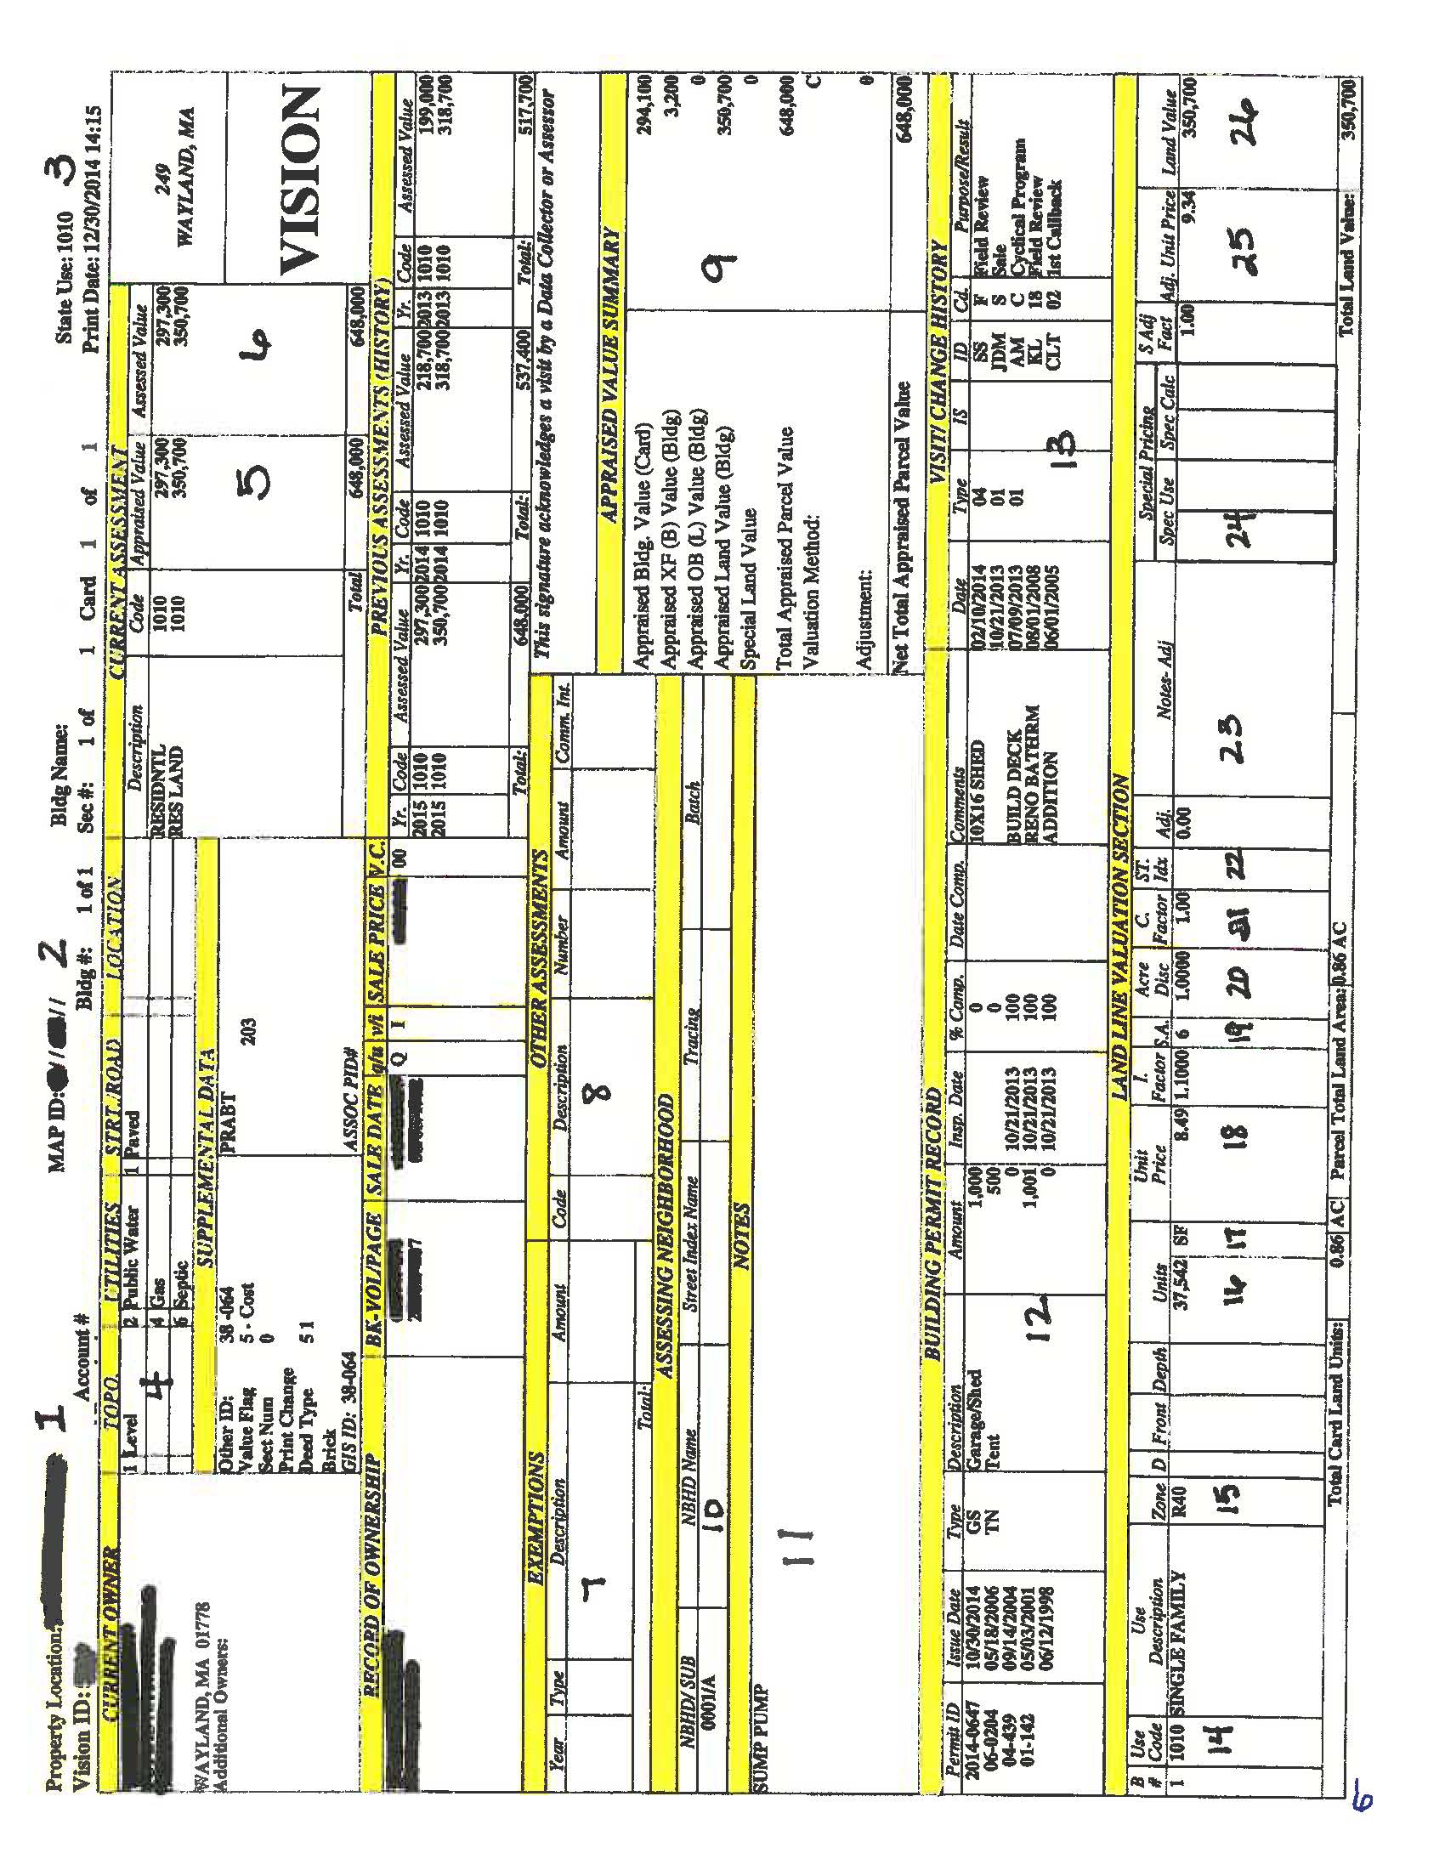
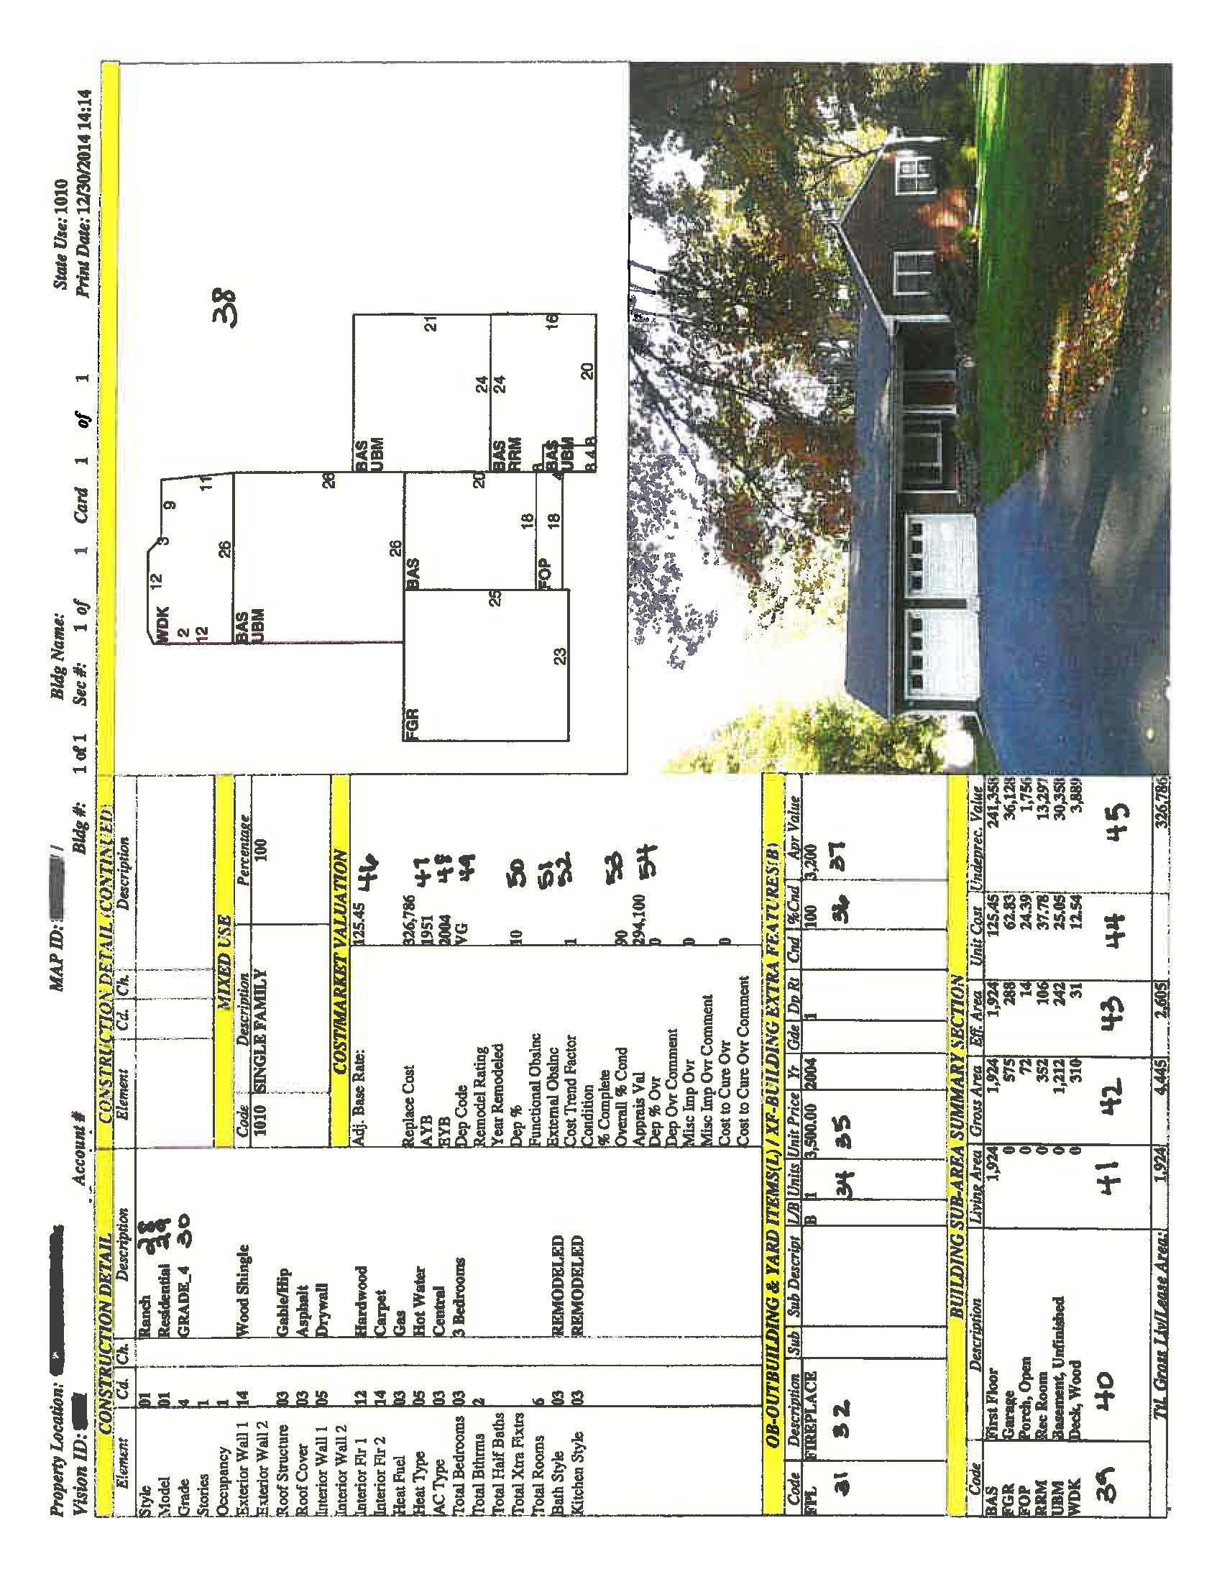
Residential Building Valuation Model
Beginning Square foot price
+/- Physical characteristics (bedrooms, bathrooms, quality of construction, flooring, fireplace etc.)
= Adjusted cost per square foot
Adjusted cost per square foot x building square footage
- Building depreciation
= Building value
Land Valuation Model
Land units
x Unit price
x Land condition adjustment
x Location adjustment
= Land value
BUILDING STYLES

Below is an explanation of typical styles of single-family residential houses.

Ranch
This style was built generally after 1940’s, although some houses were built earlier and could fall within this category. A ranch is a one-story house, which is usually rambling and low to the ground with a low-pitched roof.

Split - Level
Generally built after 1940’s. The living area is on two or more levels with each level offset to others by up to a half-story (usually 3-6 steps). It can be a front-to-back or side-to-side split or a combination of the two.

Colonial
Traditional design built from 1700’s to present. Generally 2 or 2 ½ stories with balanced openings along the main façade. Second floor overhangs are common. Newer colonials attempt to imitate this classic New England design.

Cape Cod
Generally built from the 1920’s to present. Built “close to the ground” with simple lines. A high roof ridge often supplemented with full or partial dormers may provide a second level of living area, but not a full upper story. Generally a gable roof.

Bungalow
Most bungalows were built in the early 1900’s. A small, one-story design often seen with an expansion attic area and/or dormers. Usually with an open or enclosed front porch. Narrow across the front and deep from front to back.

Conventional
An older type of house with no particular architectural design. Story heights generally range from 1.5 to 2.5 stories.

Modern or Contemporary
Constructed since 1940’s WWII. One-story, two-stories or split-level. Characterized by large windows, open planning, horizontal lines and simple details.

Raised Ranch
Typically has stairs up and down from the front entry, with the main living area on the upper level. The basement area sets on or partially below the ground level and is usually partially or totally finished.

Victorian
Traditional architectural design built during the 19th century and early 20th century. Design may include hip or mansard roof with slate tiles, two to three story heights with fenestration of unbalanced openings along main façade, a large open porch wrapping around two or three sides of house, with handcrafted mantels, dentil molding or cookie cutter details. Usually have a turret or widow’s walk on the top floor.

GRADING ADJUSTMENT METHODOLOGY

QUALITY ADJUSTMENT RATING

Introduction

A pure replacement cost system of valuation relies only on quality of materials, design and workmanship in quality grade determinants. It has been said that the three most important considerations in purchasing real estate are Location, Location and Location. Unfortunately, a pure cost system does not address what might be a major value ingredient on improvement values (Neighborhood and Location). Yes, materials, design and workmanship should be the primary quality grade determinant, but the neighborhood’s appeal, or lack thereof, may have a secondary impact. An extreme example of this is that the so-called $300,000 home in the $500,000 neighborhood will usually bring more than its pure replacement cost. Since Vision Appraisal Technology’s Appraisal System is a combination of Cost/Market Appraisal Systems, quality grades may need to vary slightly among similar neighborhoods.

QUALITY GRADING GUIDELINES

the following is a guideline used to determine general quality specifications for each grade:

Grade 11-10: | Residences of the highest quality, designed to be unique stately homes. They are normally built by an architect to the exact needs of the client and with unique and elaborate styling. Constructed with the finest quality materials and workmanship throughout the dwelling. Superior to Excellent quality interior finish and built-in features. Costs represent the highest cost in residential construction.
Grade 9-8: | Residences of very good quality are typical of those built in desirable locations and are frequently individually designed. Attention has been given to interior refinements and detail. Exteriors may have some custom ornamentation.
Grade 7-6: | Residences of good quality in above average locations and may be built for an individual owner. Design is usually from standard plans. Building is constructed with good quality materials and above average workmanship throughout. Moderate architectural treatment.
Grade 5-3: | Residences of average quality. Buildings constructed with average quality materials and workmanship throughout, conforming to the base specifications used to develop the pricing schedule. Minimal architectural treatment.
Grade 2-1: | Residences constructed with poor quality materials and fair workmanship throughout. Void of architectural treatment.

Example of some of the subareas description CODES:

CODE  BAS  BGR  CAN  CTH  EAF  EAU  FAT  FBM  FCP  FEP  FGR  CODE  FHS  FLL  FOP  FST  FUS  MDK  PTO  RRM  TQS  UAT  UBM  UEP  CODE  UGR  UHS  UST  WDK | DESCRIPTION  Base/First Floor  Basement Garage  Canopy  Cathedral Ceiling  Expansion Attic- Finished  Expansion Attic- Unfinished  Finished Attic  Finished Basement  Framed Carport  Framed Enclosed Porch  (Frame Garage)  DESCRIPTION  Finished Half-Story  Finished Lower Level  Framed Open Porch  Finished Storage Utility  Finished Upper Story  Masonry Patio/Deck  Patio  Rec Room  Three-Quarter Story  Unfinished Attic  Unfinished Basement  Unfinished Enclosed Porch  DESCRIPTION  Unfinished Garage  (Underground Garage)  Unfinished Half-Story  Utility Storage Unfinished  Deck | CRITERIA  First or primary floor, heated, finished living area.  Garage entry is located underneath the  First floor entry to home via the Basement  A roof structure with no finished floors or walls underneath.  A ceiling which is two levels in height.  A high-pitched attic roof generally found on Cape style homes. Quality of interior finish nearly equal or equal to main floor living area. May or may not have dormer coverage not exceeding 25% of total roof area Useable floor space equals 30-50% due to roofline constraints.  Same as EAF except no interior finish.  Access via permanent stairway, low pitched roof; quality of finish less than main living area. Generally found on third floor level.  Below grade level finished area that is similar in quality to the upper level(s).  Roof type structure large enough to cover an automobile. Generally two walls or more exposed to weather.  Typically uninsulated and unheated or marginally heated. Seasonal living area with finished walls, floors and ceiling.  Structure large enough for automobile storage with interior framing finished with wall and ceiling cover. (Certain projects, used on all above grade garages.)  CRITERIA  An upper level story with 50-70% of the floor area available due to roof line constraints. On a conventional style, the roof eaves are typically cut at the mid-height of the windows. On Cape style, typically an EAF with dormer coverage greater than 25% and not exceeding 50%.  Below grade level which at the level of finish as the upper level(s) of the home and has extensive windows and doors.  A roof structure with floors with at least one of its sides exposed to the weather.  Low quality storage area with finished interior (not common).  Upper floor level living space with full ceiling height and finished interior.  Brick Patio or Deck  Typically of concrete  Finished living area that is partially or fully below grade and has a level of finish that is inferior to the upper level(s), e.g., suspended ceiling, paneling sheets for walls.  Finished upper level living area with 70-90% of the floor area available due to roof line constraints. Use on Capes that have greater than 50% dormer coverage, or Conventional styles where eaves cut window above the mid-point height.  Same as FAT except that interior is unfinished. Again, must have permanent stairway, or else do not list.  Below grade unfinished area, commonly known as a cellar.  Structure that is tight to the weather, however, having no interior finish.  CRITERIA  Structure large enough to house an automobile with interior framing exposed. (On certain projects used on all garages below ground level.)  Same as FHS, except interior unfinished.  Unfinished area utilized for storage.  An open deck with no roof. Made of wood or composite material.

Please note the following building and land tables apply to residential property. For a copy of the complete FY 2020 Valuation Tables please contact the Assessing Department.

FY 2020 Residential Land Valuation Tables

Site Index Table:

Site Index | Description | Influence Factor
3 | Heavy Traffic | 0.80
4 | State Route | 0.90
5 | Avg Location | 1.00
6 | Good Location | 1.08
7 | Sub Div Avg | 1.13
8 | Sub Div Good | 1.20
L | LK Cochituate | 2.05
P | Pond Level | 1.75
Q | Pond Topo | 1.20

Land Curve Parameters:

Class | Area in Square Feet | Price
Residential | 1,000 | 145.11
Residential | 5,000 | 43.53
Residential | 10,000 | 25.39
Residential | 15,000 | 18.30
Residential | 20,000 | 15.56
Residential | 30,000 | 11.40
Residential | 40,000 | 9.09
Residential | 60,000 | 6.53

FY 2020 Single Family Building Tables

Building Style Base Rates: Building Grade Adjustments:

Building Style | Cost Group Rate |  | Grade | Factor
Ranch | 127 |  | 1 | -0.35
Split Level | 150 |  | 2 | -0.15
Raised Ranch | 143 |  | 3 | 0
Contemporary | 140 |  | 4 | 0.10
Bungalow | 128 |  | 5 | 0.30
Cape Cod | 152 |  | 6 | 0.45
Colonial | 143 |  | 7 | 0.65
Conventional | 148 |  | 8 | 0.95
Estate | 181 |  | 9 | 1.50
 |  |  | 10 | 1.85
 |  |  | 11 | 2.15

Building Size Curve:

Size Adjustment Table |  |  | Size Adjustment Table
Building Area (SF) | Size Factor |  | Building Area (SF) | Size Factor
400 | 1.67 |  | 2200 | 1.064
500 | 1.563 |  | 2300 | 1.054
600 | 1.454 |  | 2400 | 1.046
700 | 1.419 |  | 2500 | 1.037
800 | 1.371 |  | 2600 | 1.029
900 | 1.352 |  | 2800 | 1.014
1000 | 1.31 |  | 3000 | 1.000
1100 | 1.234 |  | 3200 | 0.980
1200 | 1.202 |  | 3400 | 0.960
1300 | 1.186 |  | 3600 | 0.940
1400 | 1.165 |  | 3800 | 0.920
1500 | 1.145 |  | 4000 | 0.900
1600 | 1.133 |  | 4200 | 0.885
1700 | 1.118 |  | 4400 | 0.870
1800 | 1.107 |  | 4800 | 0.855
1900 | 1.094 |  | 5200 | 0.825
2000 | 1.084 |  | 5600 | 0.79
2100 | 1.073 |  | 6000 | 0.775

FY 2020 Additional Single Family Base Rate Adjustments:

Exterior Siding | Adjustment Coefficient |  | Roof Covering | Adjustment Coefficient |  | Roof Structure | Adjustment Coefficient
Glass/Thermo. | 0.10 |  | Metal/Tin | -0.01 |  | Flat | -0.04
Pre-cast Concrete | 0.0 |  | Rolled Compos | -0.01 |  | Shed | -0.02
Precast Panel | 0.10 |  | Asphalt | 0 |  | Gable/Hip | 0
Pre-finish Metal | -0.10 |  | Tar & Gravel | -0.01 |  | Wood Truss | 0
Reinforced Concrete | 0 |  | Corrugated Asb | 0 |  | Salt Box | 0.01
Minimum | -0.16 |  | Asbestos Shingle | -0.02 |  | Mansard | 0.01
Comp./Wall Brd | -0.13 |  | Concrete Tile | 0.01 |  | Gambrel | -0.04
Below Average | -0.1 |  | Clay Tile | 0.03 |  | Irregular | 0.01
Single Siding | -0.07 |  | Enam Metal Shingle | 0.01
Concrete/Cinder | -0.05 |  | Wood Shingle | 0.02
Asphalt | -0.04 |  | Slate | 0.03
Asbestos Shingle | -0.15 |  | Rubber Membrane | 0.02
Logs | .04
Pre-Fab Wood | -0.02
Aluminum Siding | 0 |  | Bath Style | Adj. Coefficient |  | Kitchen Style | Adj. Coefficient
Average | 0 |  | Below Average | -0.01 |  | Below Average | -0.01
Board & Batten | -0.01 |  | Average/Original | 0 |  | Average/Original | 0
Cedar | 0.02 |  | Remodeled | 0.02 |  | Remodeled | 0.02
Clapboard | 0.02 |  | Remodel Custom | 0.04 |  | Remodel Custom | 0.04
Stucco on Wood | 0.02
Stucco/Masonry | 0.03
Vinyl Siding | 0
Wood on Sheath | 0
Wood Shingle | -0.01
Above Average | 0.03
Brick Veneer | 0.04
Brick | 0.06
Stone | 0.08
Interior Flooring | Adjustment Coefficient |  | Interior Walls | Adjustment Coefficient |  | Heating | Adjustment Coefficient
Dirt/None | -0.1 |  | Minim/Masonry | -0.17 |  | None | -0.05
Minimum/Plywood | -0.06 |  | Wall Board/Wood | -0.07 |  | Floor Furnace | -0.03
Concrete-Finished | -0.05 |  | Plastered | 0.02 |  | Hot Air-no Duct | -0.03
Concrete Above Grade | -0.1 |  | Plywood Panel | -0.03 |  | Forced Air-Duct | 0
Vinyl/Asphalt | -0.03 |  | Drywall | 0.02 |  | Hot Water | 0
Linoleum | -0.03 |  | Cust. Wood Panel | 0.06 |  | Steam | -0.01
Cork Tile | 0.01 |  | K PINE/A WD | 0.02 |  | Elect Baseboard | -0.03
Average | 0 |  |  |  |  | Radiant | 0
Pine/Soft Wood | 0.01 |  |  |  |  | Geothermal | 0.02
Terrazzo Monol | 0 |  | Bathroom Count | Per Unit |  | Hydro Air | 0.02
Ceram Clay Tile | 0.02 |  | Full Bath | 5,000.00
Hardwood | 0.02 |  | 3 + Full Baths | 3,000.00
Parquet | 0.02 |  | Half Bath | 2,000.00
Carpet | 0 |  | Extra Plumb Fix | 300.00
Quarry Tile | 0.02
Terrazzo Epoxy | -0.08
Precast Concrete | -0.05
Slate | 0.03
Marble | 0.04
FY 2020 Single Family Building Tables, continued

Extra Features:
CODE | DESCRIPTION | UNIT TYPE | UNIT PRICE
A/C | AIR CONDITION | S.F. | 2.5
ELV2 | PASS ELEV | UNITS | 50,000.00
FPL | FIREPLACE | UNITS | 3,500.00
FPL4 | FIREPLACE-GAS | UNITS | 2,000.00
FPL5 | METAL FIRPLACE STACK | UNITS | 1,250.00
FPMO | METAL FIREPLACE OPEN | UNITS | 750
FPO | EXTRA FPL OPEN | UNITS | 1,000.00
PCT | PADDLEBALL CRT | S.F. | 4
SNA1 | SAUNA-RES | S.F. | 80
SNA2 | SAUNA-COM | S.F. | 80
SPL4 | LAP POOL | S.F. | 350
WDST | WOOD STOVE | UNITS | 800
WHL1 | WHIRLPOOL SM | UNITS | 1,500.00
WHL2 | WHIRLPOOL SPA | UNITS | 3,500.00

Outbuildings/Yard Items:
CODE | DESCRIPTION | UNIT TYPE | UNIT PRICE |  | CODE | DESCRIPTION | UNIT TYPE | UNIT PRICE
BHS1 | CMM BTH HSE AV | S.F. | 16 |  | FGR7 | GARAGE APT UP | S.F. | 90
BHS2 | CMM BTH HSE GD | S.F. | 20 |  | FOP | OPEN PORCH | S.F. | 24
BHS3 | CMM BTH HSE PR | S.F. | 13 |  | FSP | SCREEN PORCH | S.F. | 28
BRN1 | BARN - 1 STORY | S.F. | 26 |  | GAZ | GAZEBO | S.F. | 17
BRN2 | 1 STORY W/BSMT | S.F. | 28 |  | GRN1 | GREEN HOUSE-RS | S.F. | 20
BRN5 | 2 STORY | S.F. | 32 |  | PAT1 | PATIO-AVG | S.F. | 8
BRN6 | BARN-RESID | S.F. | 26 |  | PAT2 | PATIO-GOOD | S.F. | 13
BRN9 | 1.5 STORY | S.F. | 30 |  | SHD1 | SHED FRAME | S.F. | 11
BRNF | BARN (FINISHED) | S.F. | 98 |  | SHD2 | W/LIGHTS ETC | S.F. | 18
BRNH | BARN-HORSE | S.F. | 21 |  | SHD3 | METAL | S.F. | 7
BTH1 | BATH HOUSE/CAB | S.F. | 28 |  | SPL1 | POOL-INGR CONC | S.F. | 52
BTH2 | W/PLUMBING | S.F. | 33 |  | SPL2 | VINYL/PLASTIC | S.F. | 30
CB | CABANA | S.F. | 40 |  | SPL3 | GUNITE | S.F. | 43
DCK1 | DOCKS-RES TYPE | S.F. | 32 |  | STB1 | STABLE | S.F. | 15
FEP | FIN ENCL PORCH | S.F. | 20 |  | TEN1 | TENNIS COURT | S.F. | 4.25
FGR1 | GARAGE-1 ST | S.F. | 52 |  | TEN2 | TEN COURT CLAY | S.F. | 4.5
FGR2 | GARAGE - 2 ST | S.F. | 62 |  | WDK | WOOD DECK | S.F. | 18
FGR3 | GARAGE -1.5 ST | S.F. | 58 |  | TEN2 | TEN COURT CLAY | S.F. | 4.5
FGR4 | W/LOFT-AVG | S.F | 54 |  | WDK | WOOD DECK | S.F. | 18
FGR5 | W/LOFT GOOD | S.F. | 58
FGR6 | W/LOFT-POOR | S.F. | 52

FY 2020 Single Family Depreciation Tables

Condition | Actual Age | Effective Age |  | Condition | Actual Age | Effective Age |  | Condition | Actual Age | Effective Age
Excellent | 2019 | 0 |  | Very Good | 2019 | 0 |  | Good | 2019 | 0
Excellent | 2018 | 0 |  | Very Good | 2018 | 0 |  | Good | 2018 | 0
Excellent | 2017 | 0 |  | Very Good | 2017 | 1 |  | Good | 2017 | 1
Excellent | 2016 | 0 |  | Very Good | 2016 | 2 |  | Good | 2016 | 2
Excellent | 2015 | 0 |  | Very Good | 2015 | 3 |  | Good | 2015 | 3
Excellent | 2014 | 1 |  | Very Good | 2014 | 4 |  | Good | 2014 | 4
Excellent | 2013 | 1 |  | Very Good | 2013 | 5 |  | Good | 2013 | 5
Excellent | 2012 | 2 |  | Very Good | 2012 | 5 |  | Good | 2012 | 6
Excellent | 2011 | 2 |  | Very Good | 2011 | 5 |  | Good | 2011 | 7
Excellent | 2010 | 3 |  | Very Good | 2010 | 6 |  | Good | 2010 | 8
Excellent | 2009 | 3 |  | Very Good | 2009 | 6 |  | Good | 2009 | 9
Excellent | 2008 | 4 |  | Very Good | 2008 | 6 |  | Good | 2008 | 10
Excellent | 2007 | 4 |  | Very Good | 2007 | 6 |  | Good | 2007 | 10
Excellent | 2005 | 5 |  | Very Good | 2005 | 6 |  | Good | 2005 | 11
Excellent | 2000 | 5 |  | Very Good | 2000 | 7 |  | Good | 2000 | 12
Excellent | 1995 | 5 |  | Very Good | 1995 | 7 |  | Good | 1995 | 13
Excellent | 1990 | 5 |  | Very Good | 1990 | 7 |  | Good | 1990 | 14
Excellent | 1985 | 5 |  | Very Good | 1985 | 8 |  | Good | 1985 | 15
Excellent | 1980 | 5 |  | Very Good | 1980 | 8 |  | Good | 1980 | 16
Excellent | 1970 | 5 |  | Very Good | 1970 | 8 |  | Good | 1970 | 18
Excellent | 1960 | 5 |  | Very Good | 1960 | 10 |  | Good | 1960 | 21
Excellent | 1950 | 5 |  | Very Good | 1950 | 12 |  | Good | 1950 | 25
Excellent | 1940 | 5 |  | Very Good | 1940 | 15 |  | Good | 1940 | 30
Average | 2019 | 0 |  | Fair | 2019 | 0 |  | Poor | 2019 | 0
Average | 2018 | 0 |  | Fair | 2018 | 0 |  | Poor | 2018 | 0
Average | 2017 | 1 |  | Fair | 2017 | 1 |  | Poor | 2017 | 1
Average | 2016 | 2 |  | Fair | 2016 | 2 |  | Poor | 2016 | 2
Average | 2015 | 3 |  | Fair | 2015 | 3 |  | Poor | 2015 | 3
Average | 2014 | 4 |  | Fair | 2014 | 4 |  | Poor | 2014 | 4
Average | 2013 | 5 |  | Fair | 2013 | 5 |  | Poor | 2013 | 5
Average | 2012 | 6 |  | Fair | 2012 | 6 |  | Poor | 2012 | 6
Average | 2011 | 7 |  | Fair | 2011 | 7 |  | Poor | 2011 | 7
Average | 2010 | 8 |  | Fair | 2010 | 8 |  | Poor | 2010 | 8
Average | 2009 | 9 |  | Fair | 2009 | 9 |  | Poor | 2009 | 9
Average | 2008 | 10 |  | Fair | 2008 | 10 |  | Poor | 2008 | 10
Average | 2007 | 11 |  | Fair | 2007 | 12 |  | Poor | 2007 | 13
Average | 2005 | 12 |  | Fair | 2005 | 13 |  | Poor | 2005 | 14
Average | 2000 | 14 |  | Fair | 2000 | 16 |  | Poor | 2000 | 20
Average | 1995 | 16 |  | Fair | 1995 | 19 |  | Poor | 1995 | 25
Average | 1990 | 18 |  | Fair | 1990 | 30 |  | Poor | 1990 | 30
Average | 1985 | 20 |  | Fair | 1985 | 35 |  | Poor | 1985 | 45
Average | 1980 | 22 |  | Fair | 1980 | 40 |  | Poor | 1980 | 50
Average | 1970 | 25 |  | Fair | 1970 | 45 |  | Poor | 1970 | 55
Average | 1960 | 30 |  | Fair | 1960 | 50 |  | Poor | 1960 | 60
Average | 1950 | 35 |  | Fair | 1950 | 55 |  | Poor | 1950 | 65
Average | 1940 | 40 |  | Fair | 1940 | 60 |  | Poor | 1940 | 70

FY 2020 Condominium Complex Tables

COMPLEX CODE | DESCRIPTION | ADJUSTMENT
1 | MILLBROOK | 1.50
2 | 92COMMONWEALTH | 0.86
3 | LAKESHORE DR | 1.90
4 | 260 BOSTON POST RD | 2.16
5 | TURKEY HILL | 1.27
6 | STONERIDGE | 1.02
7 | HILLSIDE | 1.00
8 | CUTTING CROSS | 0.91
9 | GLEN OAK | 0.73
10 | WILLOWBROOK | 0.82
11 | THE MEADOWS | 0.86
12 | 6 GREENWAY | 0.74
13 | GREEN WAY | 0.91
14 | FLD MAINSTONE | 0.91
15 | 16 KING STREET | 1.32
16 | 526 BSTN POST | 0.90
17 | 16 WILLARD ST | 1.47
18 | 311 BSTN POST | 2.60
19 | RESIDENCES AT 89 OXBOW | 1.00
20 | WAYLAND GARDENS | 0.86
21 | SCHOOL ST | 1.53
22 | WAYLAND COMMONS | 0.87
23 | POST RD VILLAGE | 1.06
24 | SAGE HILL | 0.88
25 | RIVER TRAIL PLACE | 0.99
18-34 | COVERED BRIDGE LN | 0.96
31 | CRAFTSMAN VILLAGE | 0.97
33 | HABITAT HOMES | 1.00
34 | COVERED BRIDGE | 0.50
35 | 45 WEST PLAIN ST | 1.05

Condominium building tables mirror the Single Family Residential Tables with the exception of complex adjustments. These adjustments are applied to account for the market and are developed by analyzing all the sales within a complex.

